Data Flow Diagrams:

Project Design Phase-II

Data Flow Diagram & User Stories

Date | 01 November 2025
Team ID | 69c0be5ec71a9ebd6a51912e
Project Name | Streamlining Ticket Assignment for Efficient Support Operations
Maximum Marks

Data Flow Diagrams (DFDs) illustrate how incoming tickets are processed and routed within the system. The DFD shows the interaction between the End-User (submitting the request), the ServiceNow System (specifically Flow Designer), and the Operations Related database table.
The DFD depicts how the system intercepts the new ticket data to validate the 'Issue' field against predefined conditions. If the issue matches a specific criterion (e.g., "Regarding Certificates"), the system automatically processes an update to populate the "Assigned to group" field, routing the ticket to the correct support team and ensuring efficient resolution.
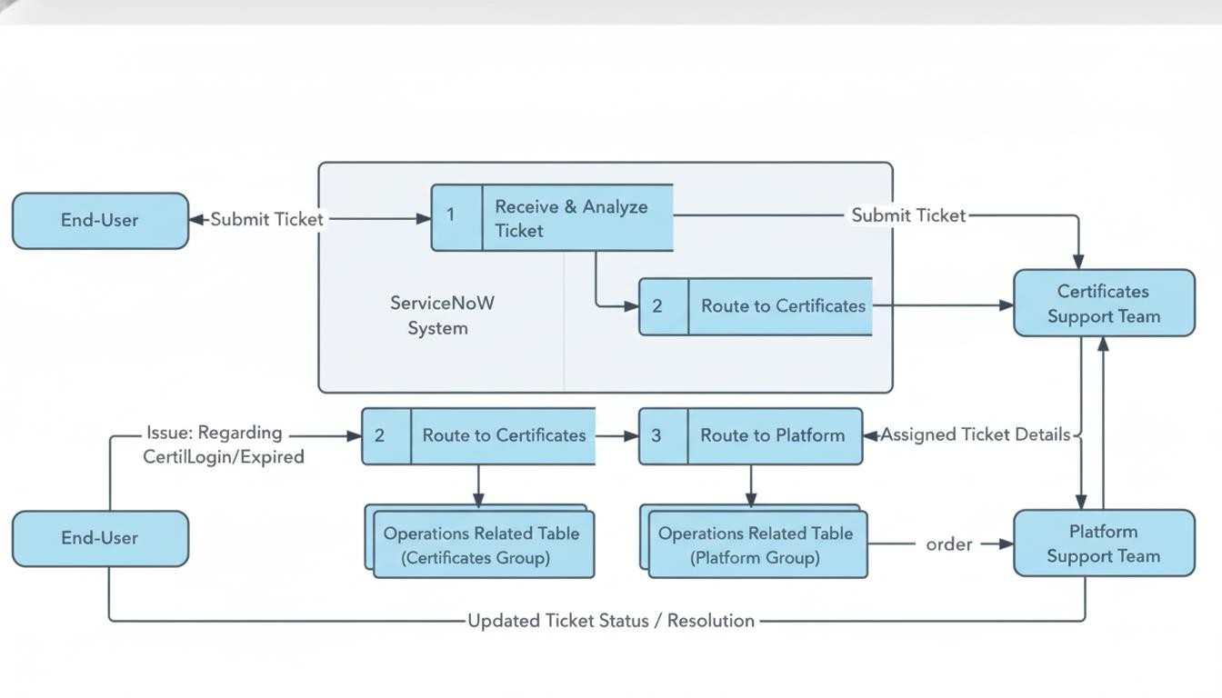

User Stories:

User stories define what different users need from the system in simple, goal-focused language. In this project, they help ensure that support tickets are automatically routed to the correct team based on the issue type, reducing manual effort and resolution time.

User Type | Functional Requirement (Epic) | User Story Number | User Story / Task | Acceptance Criteria | Priority | Release
End-User | Ticket Submission | USN-1 | As an End-User, I want to submit a ticket for my "Operations related" issue. | The system must allow me to select an issue from a list (e.g., "Unable to login," "Regarding Certificates"). | High | Sprint-1
System (Auto- check) | Automated Ticket Routing | USN-2 | As the system, I must check the "Issue" field when a new "Operations related" ticket is created or updated. | If the "Issue" is "Regarding Certificates", the system must assign the ticket to the "Certificates" group. | High | Sprint-1
System (Auto- check) | Automated Ticket Routing | USN-3 | As the system, I must check the "Issue" field when a new "Operations related" ticket is created or updated. | If "Issue" is "Unable to login", "404 error", or "Regarding user expired", the system must assign the ticket to the "Platform" group. | High | Sprint-1
Support Agent (Platform) | Ticket Queue Management | USN-4 | As a Platform Support Agent, I want to see only tickets relevant to my team in my group's queue. | When a ticket is assigned to the "Platform" group, it appears in my queue. Tickets for "Certificates" do not. | Medium | Sprint-1

